* **Lab Task 5:**

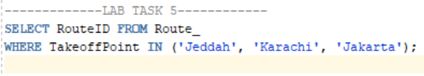**Display the route IDs for routes originating from airports in 'Jeddah', 'Karachi', and 'Jakarta'.**

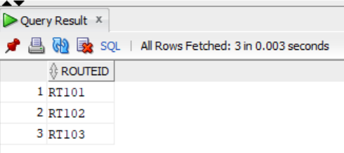OUTPUT: